H.T No
Regulations:
A17

Sreenidhi Institute of Science and Technology
(An Autonomous Institution)
Code No: 6A304 Date: 26-Oct-2021(FN)

B.Tech II-Year I- Semester External Examination, Sept/Oct - 2021 (Supplementary)
Circuits AND Networks-II (EEE)

Time: 3 Hours Max.Marks:75

Note: a) No additional answer sheets will be provided.
b) All sub-parts of a question must be answered at one place only, otherwise it will not be valued.
c) Missing data can be assumed suitably.

ANSWER ANY 5 OUT OF 8 QUESTIONS. EACH QUESTION CARRIES 15 MARKS.

Bloom's Cognitive Levels of Learning (BCLL)

Remember | L1 | Apply | L3 | Evaluate | L5
Understand | L2 | Analyze | L4 | Create | L6

 |  |  | BCLL | CO(s) | Marks
1. | a) | A 3-ϕ motor can be regarded as a balanced Y-load. A 3-ϕ motor draws 5.6KW when the line voltage is 220V and the line current is 18.2A. Determine the power factor of the motor. | L5 | CO1 | [8M]
 | b) | The two wattmeter method produces wattmeter readings P₁=1560W and P₂=2100W. When connected to a delta connected load. If the line voltage is 220V, Calculate  (i) The per phase average power.  (ii) The per-phase reactive power.  (iii) The power factor. | L4 | CO1 | [7M]
2. | a) | An ac voltage of v = V Sin 500πt is applied to a series R-L circuit. If the L-R circuit has R=10Ω and L=0.1H, calculate the ratio of maximum value to which the current rise to the steady state maximum value when the voltage is applied at an instant, t= 0.002 sec. | L5 | CO2 | [8M]
 | b) | A series R-C circuit has R=20Ω and C=100μF. A voltage v = 200 Sin 314t is applied at t=2.14msec. Obtain an expression for current i. Also, find the value of current after time 1m sec from the switching instant. | L5 | CO2 | [7M]
3. | a) | Write necessary conditions for transfer functions. | L1 | CO3 | [8M]
 | b) | Find the driving point impedance for the network shown in below figure.  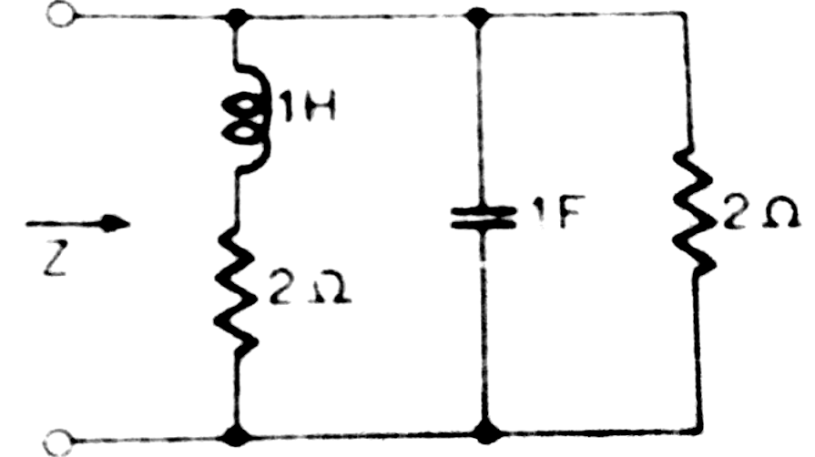 | L5 | CO3 | [7M]
4. |  | In the circuit shown in below figure, find the i) h-parameters.  ii) ABCD parameters  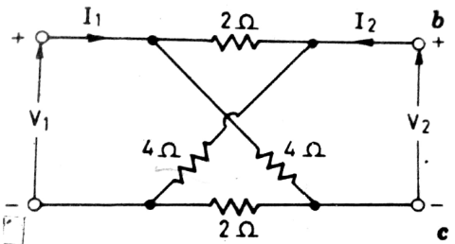 | L5 | CO4 | [15M]
5. | a) | Write about constant-K filters. | L1 | CO5 | [8M]
 | b) | Write about analysis of m-derived low pass filter. | L1 | CO5 | [7M]
6. | a) | Find the exponential Fourier series expansion of the periodic function  f(t)=e^{t}, 0 < t < 2π with f(t+2π)=f(t). | L5 | CO6 | [8M]
 | b) | Find the complex Fourier series of the saw tooth wave shown in below figure. Plot the amplitude and the phase spectra.  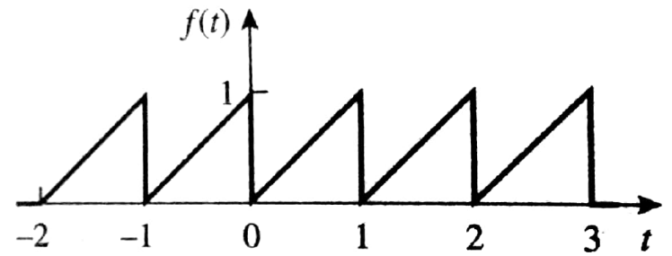 | L5 | CO6 | [7M]
7. | a) | The power input to a 3-ϕ motor is measured by two wattmeter’s which indicate 300KW and 100KW respectively, the latter reading being obtained after the reversal of its current coil. Find the power factor of the motor. | L5 | CO1 | [5M]
 | b) | In given figure find the expression for current at t=0+, following switching (opening of Switch). Assume steady state when S was closed.  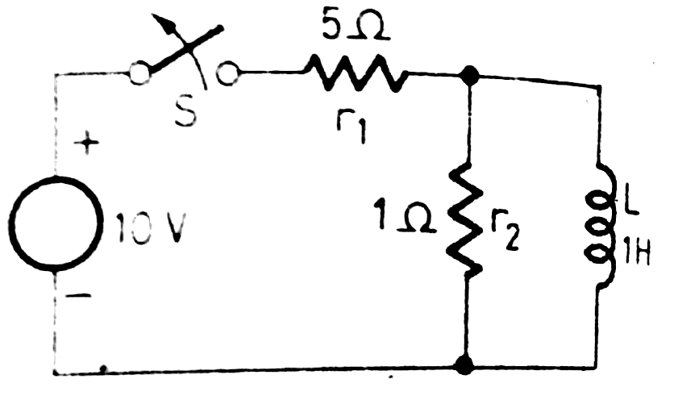 | L5 | CO2 | [5M]
 | c) | Write the properties of driving point function. | L1 | CO3 | [5M]
8. | a) | Write condition for reciprocity and symmetry in terms of two port network parameters. | L1 | CO4 | [5M]
 | b) | In a R-L type Low Pass Filter, assuming 10V input, find the output voltage for operation at 1KHz. Assume L=159.15mH and R= 500Ω. | L3 | CO5 | [5M]
 | c) | Explain the properties of Fourier transforms. | L2 | CO6 | [5M]

-- 00 -- 00 –

